

Foundations of Programming

Assignment No.: 07
PROBLEM STATEMENT: Write a C program to accept student details and display their result using an array of structures.

OBJECTIVE:

- To understand the concept of structures in C.
- To learn how to store multiple records using an array of structures.
- To accept and process student details such as name, roll number, and marks.
- To calculate total and percentage and display the result.

THEORY:
In C programming, a structure is a user-defined data type that allows grouping of variables of different data types under a single name. When multiple records such as student details need to be stored, an array of structures is used. This allows efficient storage and processing of student information like roll number, name, and marks in different subjects. The program can compute total marks and percentage and display the result for each student.
PLATFORM: C Compiler
ALGORITHM:
Step 1: Start the program.
Step 2: Declare a structure named student with members:
• roll number
• name
• marks[3]
• total
• percentage
Step 3: Ask the user to enter the number of students n.
Step 4: Create an array of structures to store n student records.
Step 5: For each student:
a. Accept roll number
b. Accept name
c. Accept marks of 3 subjects
d. Calculate total = sum of marks
e. Calculate percentage = total / 3
Step 6: Display all student details with:
• Roll number
• Name
• Total marks
• Percentage
Step 7: Stop.

FLOWCHART :
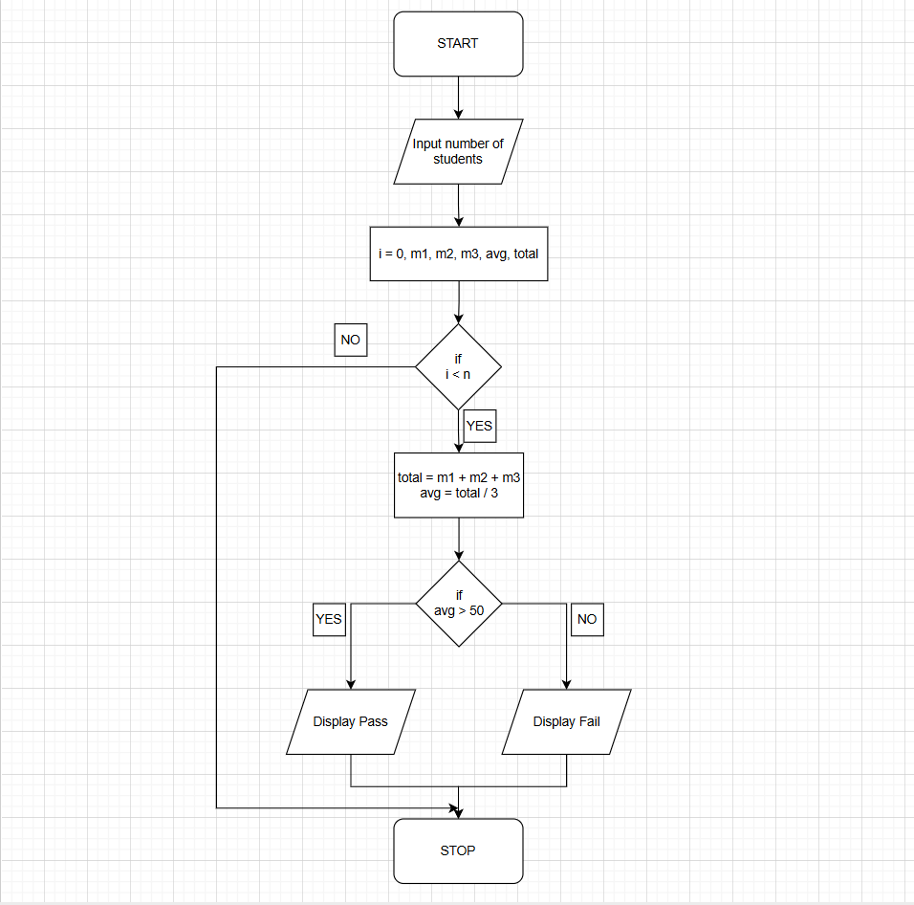

CODE :
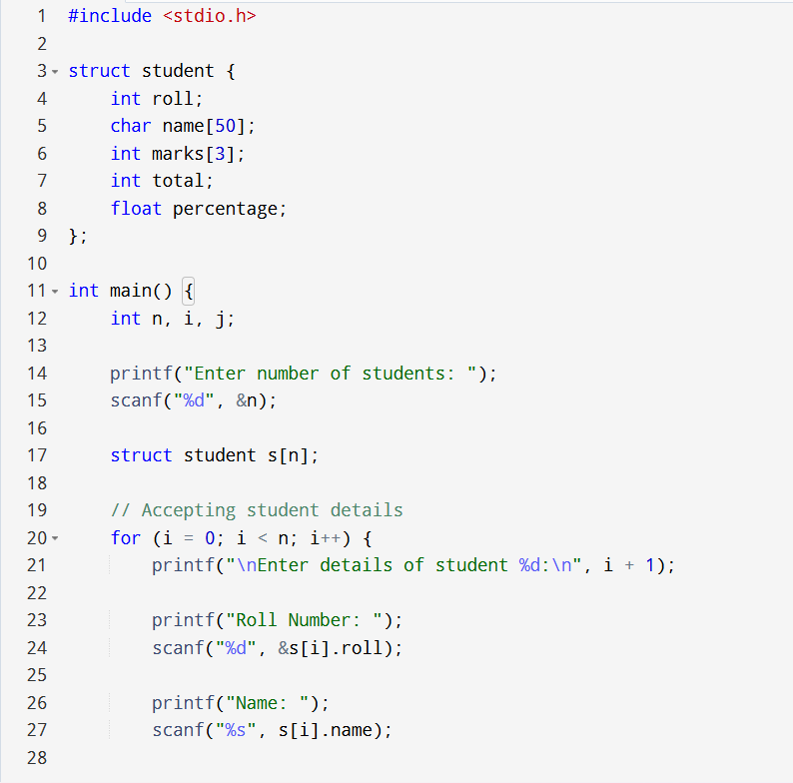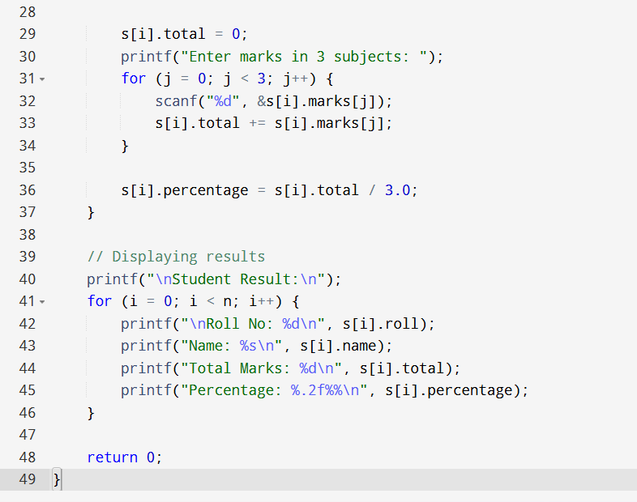
INPUT: Student roll number, name, and marks in three subjects.
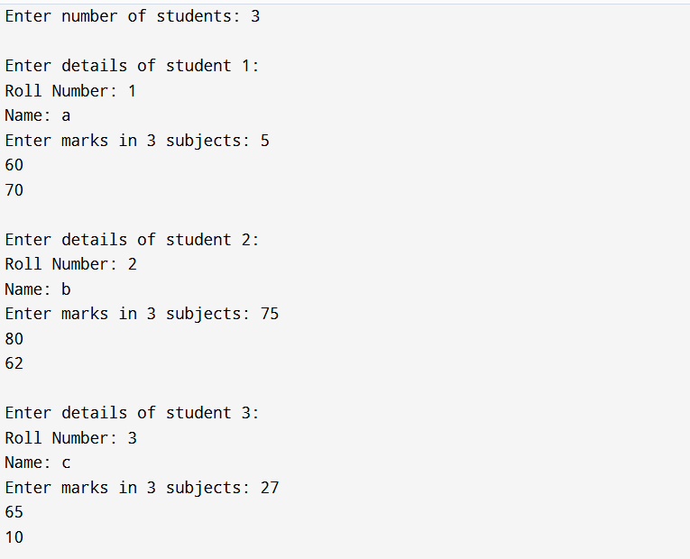

OUTPUT: Displays student details along with total marks and percentage.
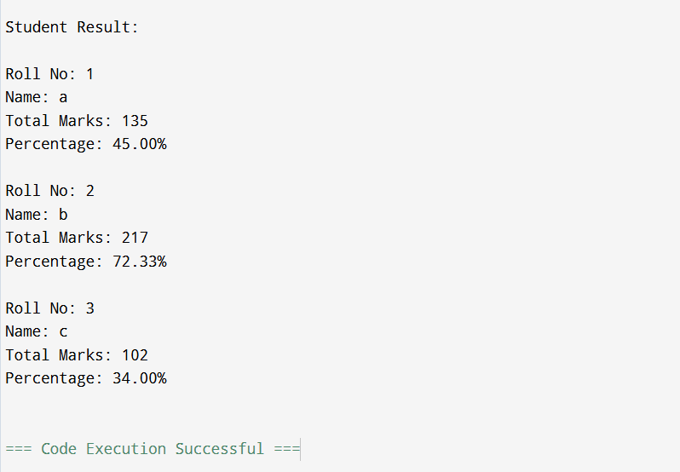

SAMPLE INPUT:
Enter number of students: 1
Roll Number: 101
Name: Rahul
Marks in 3 subjects: 80 75 90

SAMPLE OUTPUT:
Student Result:
Roll No: 101
Name: Rahul
Total Marks: 245
Percentage: 81.67%
CONCLUSION: Thus, the C program successfully accepts student details using an array of structures and displays the calculated result including total marks and percentage.

FAQs:
- What is a structure in C?
- What is the difference between a structure and a union in C?
- What is an array of structures?
- Why are structures used in C programming?
- What is the advantage of using an array of structures?

